PSG COLLEGE OF TECHNOLOGY
DEPARTMENT OF COMPUTER APPLICATIONS
I MCA
23MX17 DATA STRUCTURES LABORATORY
PROBLEM SHEET – Linked List
- Write a program to create a singly linked list and perform the following .
- To insert a new node at the beginning
- To insert a new node at a specified position
- To insert a new node at the end
- To delete a node at the beginning
- To delete a node from a specified position
- To delete a node at the end.
- Display the list in reverse order
- Count the number of nodes.
- Merging of two linked list.
- Sort a linked list
- Swap nodes in a linked list without swapping data
- Intersection point of two Linked Lists.
- Find length of loop in linked list (checks whether a given Linked List contains loop and if loop is present then returns count of nodes in loop)
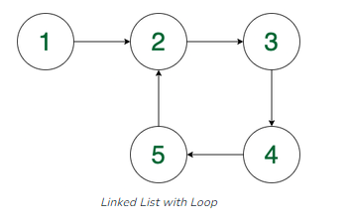
Output: 4
Explanation: The loop is present in the linked list and the length of the loop is 4.
https://codeforwin.org/data-structures/c-program-to-create-and-traverse-singly-linked-list#google_vignette
https://www.programiz.com/dsa/linked-list-operations

